10-1 Cell Growth
Living things grow by producing more cells
If cells grew without limits an “information crisis” would occur
Food, oxygen, and water that enters and waste that exits limits cell growth due to surface area of cell membrane
Before cell becomes too large it divides and forms 2 daughter cells (cell division)
Each daughter cell gets one complete set of genetic information
Eukaryotes – cell division occurs in 2 main stages:
- Mitosis – cell nucleus divides
- Cytokinesis – division of cytoplasm
Unicellular organisms reproduce by mitosis and cytokinesis (called asexual reproduction)
Draw and label Fig 10-3 on page 244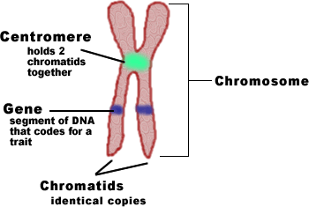

10-2 Cell Division
- Chromosomes – human cells have 46 chromosomes (23 pairs)
Chromosomes are not visible in most cells except during cell division
Well before cell division each chromosome is replicated (a copy is made). Because of this, each chromosome consists of two identical “sister” chromatids. Each of these chromatids is attached at an area called a centromere usually located in the middle
- The Cell Cycle:
Cell cycle – the series of events that cells go through as they grow and divide.
During the cell cycle, a cell grows, prepares for division, and divides to form two daughter cells, and each of them begin the cycle again.
The cell cycle consists of four phases. Mitosis and cytokinesis take place during the M phase. Chromosome replication, or synthesis, takes place during the S phase. When the cell copies the chromosomes, it makes a duplicate set of DNA. Between the M and S phases are G1 and G2. The “G” in the names of these phases stands for “gap,” but the G1 and G2 are definitely not periods when nothing takes place. They are actually periods of intense growth and activity. (Page 245)
*Copy diagram Figure 10-4 into notes page 245
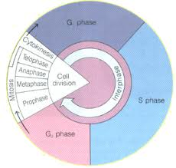
- Events of Cell Cycle:
Interphase is divided into 3 phases G1, S, and G2.
G1 – cells do most of their growing
S phase – chromosomes are replicated and the synthesis of DNA molecules takes place
G2 phase – shortest of three phases organelles and molecules required for cell division are produced
- Mitosis:
Divided into four phases: prophase , metaphase, anaphase and telophase
Depending on type of cell, the four phases can last from a few minutes to several days
- Prophase – first and longest, chromosomes become visible, centrioles (tiny structures in cytoplasm) separate and take up positions on opposite sides of the nucleus, spindle begins (fanlike microtubule that helps separate the chromosomes). Plant cells do not have centrioles, but still organize their mitotic spindles from similar regions. Near end of prophase: nucleolus disappears and nuclear envelope breaks down.
- Metaphase – second phase, often lasts only a few minutes, chromosomes line up at center of cell, microtubules connect centromere of each chromosome to spindle
- Anaphase – third phase, centromeres split allowing sister chromatids to separate and become individual chromosomes, ends when chromosomes stop moving
- Telophase – fourth and final phase, chromosomes begin to disperse into a tangle of dense material, nuclear envelope reforms
Copy Figure 10.5 into notes Page 246-247
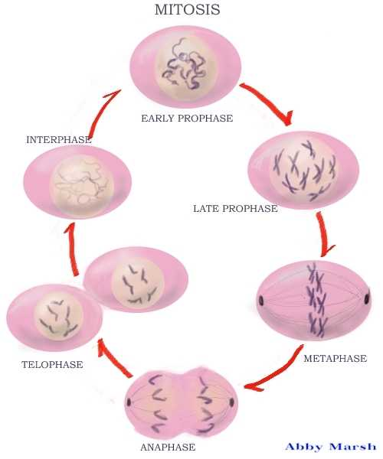

- Cytokinesis:
  - Division of cytoplasm itself
  - Occurs at same time as telophase
  - In most animal cells, cell membrane is drawn inward until the cytoplasm is pinched into two nearly equal parts
  - In plants, cell plates form midway between the divided nuclei
10-3 Regulating the Cell Cycle
Examine Figure 10.7 Cells in a petri dish growing until they come in contact with other cells
Proteins, known as cyclins, are involved in cell cycle regulation and they regulate the timing of the cell cycle in Eukaryotic cells.
Internal regulators – proteins that respond to events inside the cell
External regulators – proteins that respond to events outside the cell, especially important during embryonic development and wound healing
Cancer – the body’s own cells lose the ability to control growth, have a defect in a gene called p53

